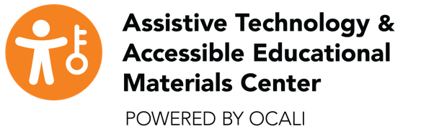

Request for a Textbook Chop and Scan
Request Number:
Date:
Title:
ISBN Number:
Publisher:
Copyright Date:
Requestor Name:
Telephone Number:
Summer Number:
Facility Name:
Facility Fax:
School District:
County:
Teacher Email:
Summer Email:
Student Name:
*Date of Birth:
*Requestor Signature:
This will verify the school district’s intent to comply with copyright requirements and allow the school to request accessible materials. The student will have access to a print copy of the requested textbook.
Please complete and mail this form and the format clarification form with a print textbook via FREE MATTER FOR THE BLIND to: AT& AEM Center
ATTN: Kelly Houston or Judy Siens
470 Glenmont Ave
Columbus OH 43214

