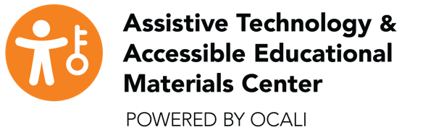

Request for a NIMAS File
Request Number:
Date:
Title:
ISBN Number:
Publisher:
Copyright Date:
Requestor Name:
Telephone Number:
Summer Number:
Facility Name:
Facility Fax:
School District:
County:
Teacher Email:
Summer Email:
Student Name:
*Date of Birth:
*Requestor Signature:
This will verify the school district’s intent to comply with copyright requirements and allow the school to request accessible materials. The student will have access to a print copy of the requested textbook. The student for whom this request was submitted has an Ohio Certification of Eligibility to use NIMAS Materials form on file at the school district of attendance.
Please complete and mail this form and the format clarification form with a print textbook via FREE MATTER FOR THE BLIND to: AT& AEM Center
ATTN: Kelly Houston or Judy Siens
470 Glenmont Ave
Columbus OH 43214

