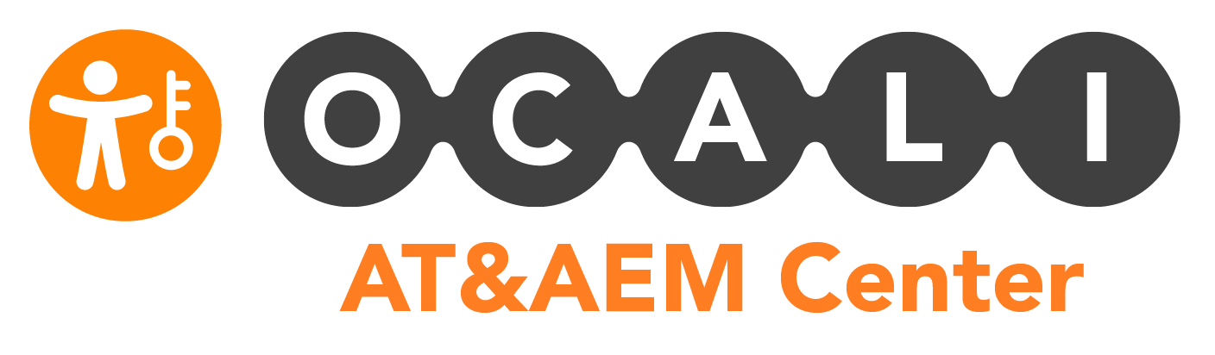

Helpful Hints for Using Teams: For the Participant

Signing In and Setting Up!
- If you do not already have a Microsoft Teams account, you will need to sign up for free through Microsoft. If your employer does not support Microsoft Teams, you may need to use a personal email account, or create a new account for free.
- You may want to download the Microsoft Teams app to your desktop or mobile device to create easier access to courses and related content.
- If you are using a mobile device you may also want to download related Microsoft applications, such as Word or PowerPoint.
- If your device or your issued device will not allow you to download the Microsoft Teams app, you can use the web browser version for a similar experience!

Quick Tips for General Channels
- Making comments on the Posts tab in General are public posts and anyone in the team can see them. Feel free to use this feature to reach out to your peers, post encouraging messages, share successes or struggles, and share resources!
- You can also post questions to the General Questions channel. Ask someone a question directly by using @insertname, to ask them a question- this way they will get a notification that you asked them!
- If you have any questions or difficulty accessing the content, please do not hesitate to reach out to the instructor or a member of the AT&AEM Team.

Quick Tips for Training Channels
- If you have participated in BEST Grant trainings and indicate that you have on the registration form, you will be added to training specific channels! In these channels, all training resources we have will be housed there.
- If when you joined the community, you had not participated in BEST trainings, and since joining the network you have participated in a training, you can submit a request to be added to the training channel by completing this very short form!
- Course resource materials can be found under the Files tab – these will include handouts, resource articles, and more shared by the instructor of the course.
- Course recordings can be found under the Session Recordings tab. All session recordings for the course can be streamed from this tab!
  - Captions are available with this feature, and you can turn captions on by clicking on the CC button after clicking play on the video!
  - If a training has multiple sessions, the sessions will be labeled.
  - If a training does not have a Session Recordings tab, and you need to access a recording, please reach out to Augusta Fisher at augusta_fisher@ocali.org so that the correct recordings can be linked to the channels!
- If your course has a Class Notebook tab, you can open that tab to view notes about the training from the instructor. Feel free to use these to follow along!

